
Ahram Canadian University Faculty of Computer Science & IT
Data Science

Data Science Project
Early stage diabetes risk prediction dataset. Data Set

Names | IDs
Yasmeen Ayman Mohamed | 41810051
Shrouk Yasser yousef | 41810072
Doaa Mamdouh Hussien | 41810038
Maram Mohammed | 41810178
Nada Elsayed yousef | 41810306

Supervised by:
Dr. Ghada Khoriba
Eng.: Ahmed Kamal
Eng.: Mai

Abstract
Nowadays, diabetes is one of the fastest growing chronic life threatening diseases has become a common disease to the mankind from young to the old persons.The growth of the diabetic patients that has already affected 422 million people worldwide according to the report of World Health Organization (WHO), in 2018, now also it is increasing day by-day due to various causes such as bacterial or viral infection, toxic or chemical contents mix with the food, auto immune reaction, obesity, bad diet, change in lifestyles, eating habit, environment pollution, etc. Hence, diagnosing the diabetes is very essential to save the human life from diabetes. Around 50% of all people suffering from diabetes are undiagnosed because of its long-term asymptomatic phase is a chronic disease or group of metabolic disease where a person suffers from an extended level of blood glucose in the body, which is either the insulin production is inadequate

Introduction
Diabetes is one of deadliest diseases in theworld. It is not only a disease but also a creator of different kinds of diseases like heart attack, blindness, kidney diseases, etc. The normal identifying process is that patients need to visit a diagnostic center, consult their doctor, and sit tight for a day or more to get their reports. Moreover, every time they want to get their diagnosis report, they have to waste their money in vain. Diabetes Mellitus (DM) is defined as a group of metabolic disorders mainly caused by abnormal insulin secretion and/or action

Data description
This dataset contains reports of diabetes-related symptoms of 520 persons [37]. It includes data about peoples including symptoms that may cause diabetes. This dataset has been created from a direct questionnaire to people who have recently become diabetic, or who are still no diabetic but having few or more symptoms. The data has been collected from the patients using direct questionnaire from Sylhet Diabetes Hospitalof Sylhet,Bangladesh.The data pre-processing has been conducted by handling the missing values following the technique of ignoring the tuples with incomplete values.

Data Set Information:

This has been collected using direct questionnaires from the patients of Sylhet Diabetes
Hospital in Sylhet, Bangladesh and approved by a doctor.

Problems to solve

The effect of adapted sports physical activity on the psychological aspect of diabetes.
The effectiveness of a preventive counseling program to reduce the risk of developing diabetes in a sample that has risk factors for diabetes.

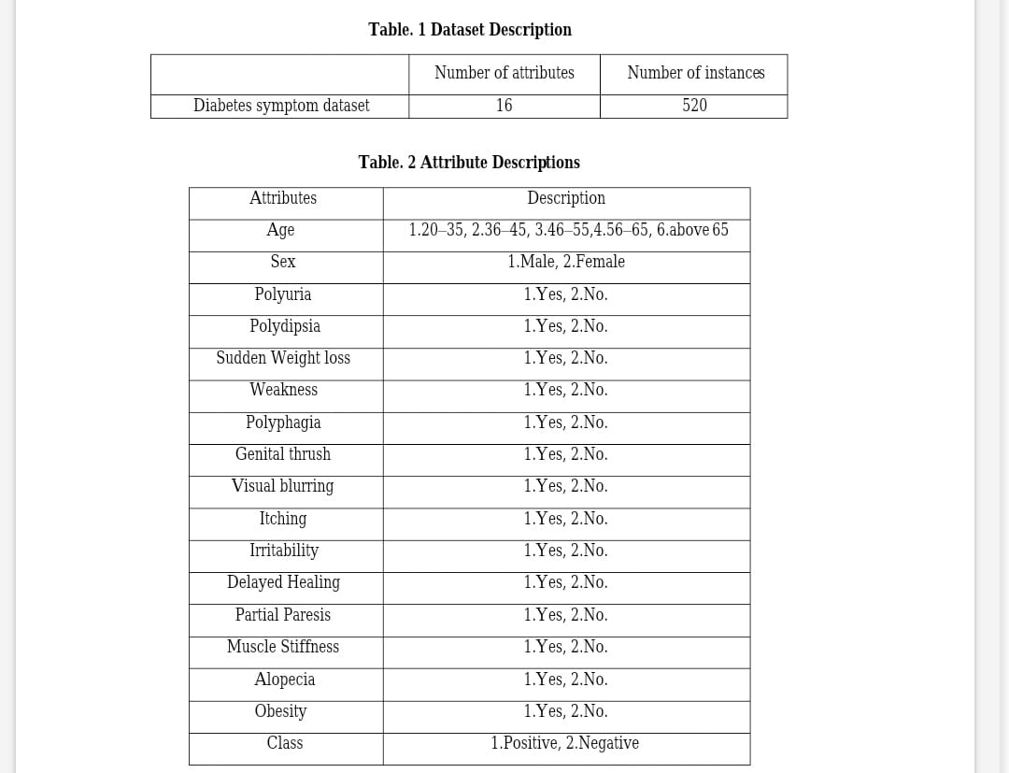

Source:

1. M M Faniqul Islam,
2. Rahatara Ferdousi,
3.Sadikur Rahman,
and Humayra
4.Yasmin Bushra
1. Queen Mary University of London, United Kingdom
m.islam '@' smd17.qmul.ac.uk
2. Metropolitan University Sylhet, Bangladesh
rahatara '@' metrouni.edu.bd
3 . Metropolitan University Sylhet, Bangladesh
rahmansadik004 '@' gmail.com
4 .Metropolitan University Sylhet, Bangladesh
humayrabushra234 '@' gmail.com

